5/2/2022
Submitted To:

Vendors of LWAB & Jericho Youth Services Mom To Mom Sale
Sunday May 15 2022
10am – 12:00pm
East Gwillimbury Sports Complex – Canada Room

RE: Annual Spring Mom To Mom Sale ~ Vendor Day Of Procedures

Dear Vendors:

On behalf of the team at Life With A Baby & Jericho Youth Services, we'd like to thank you for choosing to particapte in our Annual Spring LWAB Mom to Mom Sale!! The team is very excited about the success of this sale each year and the ability to bring it back again to our local community and members.

BACKGROUND: Life With A Baby is a charitable organization whose goal is to provide ongoing practical and emotional PEER-based support for new and expecting parents, and parents of children up to the age of six. We offer informational seminars and programs, open forums, and fun social events. Healthy parenting leads to happy and healthy children! We are proud to have a member base of over 20,000 members and growing!. To learn more about Life With a Baby please visit www.lifewithababy.com

Jericho Youth Services delivers recreational and leadership programs to children and youth in Georgina since 1982. We are dedicated to educate and empower our youth in becoming engaged and caring citizens of the community and providing children and youth with opportunities that enhance well-being through social, emotional and physical development by providing affordable and safe programs. Most of our programs are offered to families free of charge or at a low price.

PURPOSE: The purpose of this mom to mom sale is to give our members a chance to sell their unwanted baby items, as well as other members to purchase items at great prices. In addition, we want to support our local mompreneurs and businesses by offering an affordable marketing opportunity. This event is being put on exclusively on a voulenteer basis and with very nominal table fees to cover costs. In exchange, we are asking for your cooperation with these vendor procedures in order to make the sale as successful and seamless as possible (PLEASE READ THEM CAREFULLY!).
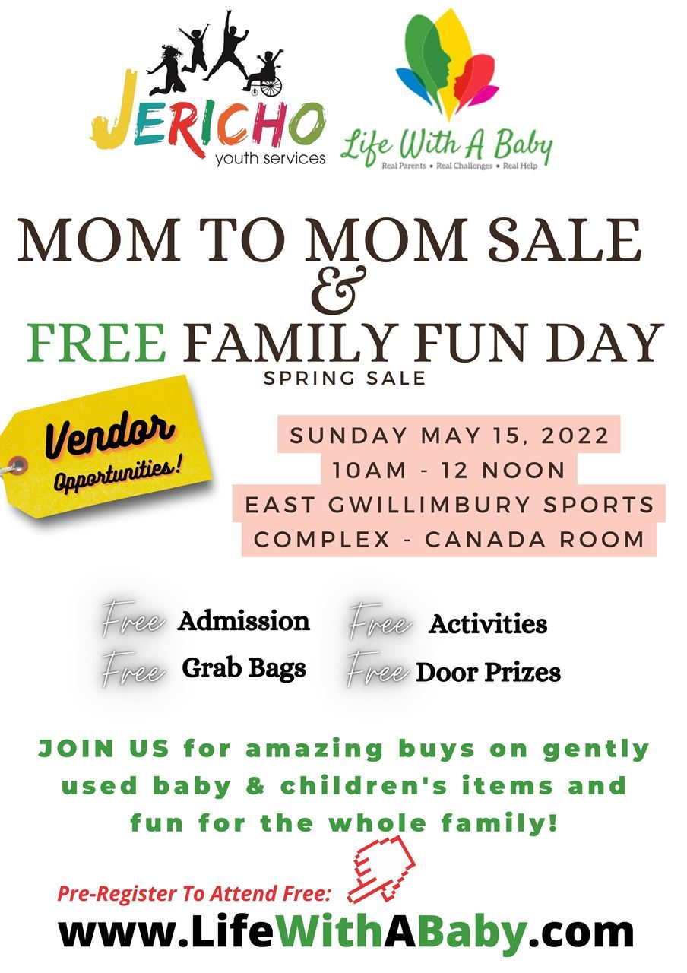
Please do not hesitate to contact us, should you have any questions or concerns.

Looking forward to thrifting with you!

Connie Butera
Event Organizer & Community Manager
LWAB York Region North Chapter
T. 416.885.9709
E. connie@lifewithababy.com
W. www.lifewithababy.com
www.facebook.com/LWABYorknorth

Tracy McCulloch
Co-Host
Jericho Youth Services
T. 905 722 5540
E. tracy.mcculloch@jerichoys.org
W. www.jerichoyouthservices.org
https://www.facebook.com/JerichoYouth

Vendor Sale Day Procedures:
Location: East Gwillimbury Sports Complex – Canada Room
1914B Mt Albert Rd, Sharon, ON L0G 1V0

Time: Registration & Set-up begins at 9:30AM (no sooner!). Sale is from 10am-12pm (no early set up or early clean up!). Clean up goes until 12:30 (you must be out by this time!). Please pack your items ready to go, prices in bins for easy place and sell and to maximize you set up / tear down time.

What You Get:

PERSONAL SALES TABLES: One 5” round or 6” rectangular table + 1 chair
Floorplan and placement done at the discretion of the event organizers

BUSINESS TABLES: One 6 rectangular table + 1 chair + opportunity to place an entry into 100 grab bags + opportunity to place entry in our door prize draws. We ask that each business vendor put an item of value in for the door prize draw and bring with with you the day of the event for display. If you require additional chairs for additional people at your table, please note this in your event registration or to the organizers.

Procedures:

- Arrival at 9:30am to set up as a vendor. NO NEED TO CHECK IN / REGISTER. We will be setting the floorplan in advance and assign you a table. You will be emailed with the floorplan and your assignment. PLEASE JUST FIND YOUR TABLE ON ARRIVAL AND BEGIN SETTING UP. Tables are being assigned randomly based on registrations and best placement for shopping experience. You may not choose your table or location, however if enough notice is given we can make some reasonable considerations for being near / beside friends. We set up our show with BUSINESS & PERSONAL SALES tables throughout the show floor i.e. mixed in together. We find this better for the shopping experience and getting people to your table. Once you know your table number, you can find it in the venue (each will be marked by number and a floorplan posted). You may then proceed with set up. No need to register or check in on your arrival. **please bring help to carry your items inside / set up or be prepared to do it on your own OR bring a dolly / cart if needed**
- Set up is from 9:30 a.m.-10am. ALL VENDORS MUST BE IN SETUP BY 10:00 a.m when the show starts. Please do not come earlier than 9:30am as the tables will not be set up yet and you will have to wait outside.
When setting up, please do not impede aisles. This includes the corners and in front of your table, you will be asked to remove excess items (this is a FIRE CODE requirement). Your items MUST stay ON / behind or UNDER your table (without disturbing your neighbouring tables and the isles). We have created a stroller friendly floor plan. You can welcome to bring some larger items or a coat rack, so long as you can keep in in your area and no impede on your neighbour / aisle.

WE ENCOURANGE YOU TO KEEP YOUR ITEMS ON, UNDER OR BEHIND YOU TABLE, HOWEVER IF YOU PREFER TO USE A SMALL RACK, YOU MAY HAVE 1 RACK OF CLOTHING BESIDE OR BEHIND YOUR TABLE, SO LONG AS IT DOES NOT IMPEDE ON THE SPACE OF YOUR NEIGHBOUR.
3. The venue has requested that STICKERS i.e. the dollar store pricing stickers NOT BE USED as they tend to fall off and onto the floor and are difficult to remove later on. Please remove anything that may have got stuck to the floor from your table display. We recommend labelled bins of clothing that are organized by type / size. Signage for your table with the gender gender/ size of clothing you are mostly selling can also be helpful.

4. Tear Down – Please ensure you take all empty boxes / bins / unsold items and garbage with you. Garbage and recycling containers will be available at the event for reasonable amounts of paper garbage only. Bring home whatever you brought! And bring whatever garbage bags you need or containers for excess. DO NOT LEAVE UNSOLD ITEMS AT THE VENUE. You can take them to a local thrift store after the event, should you choose. (Some Suggestions ~ Once Upon A Child, Value Village, etc.). The choice is up to you!
5. EVENT MARKETING ~ Encourage your friends, family and followers to attend. Feel free to promote the event to your personal networks, playgroups, facebook groups and more.

Use this website link to promote the sale & free family fun day:
- www.lifewithababy.com/event-4753677 for those interested in vendor tables
- www.lifewithababy.com/event-4779898 for those wanting to come to the sale / fun day
- Use this Facebook event link
https://www.facebook.com/events/533333398153861/?acontext=%7B%22event_action_history%22%3A[%7B%22surface%22%3A%22page%22%7D]%7D

We have made every effort as an organization to market this event to our members and networks via eblasts and online SOCIAL & ONLINE COMMUNITY GROUP marketing. We also rely on your support to get the word out in order to maximize attendance at this event!

SELLING TIPS
Please remember to price everything appropriately. If you price your items high you will end up going home with everything. Shoppers don't care how long you have had it, how often it was used or worn, or how expensive it was when you bought it!!! Price it right and get rid of it!

If you have bins of clothes, then categorize them by size, gender and offer great incentives on bulk purchases. People love $1 bins!!! Packaging items in clear bags is also sometimes helpful. Remember to avoid stickers!

If you have any really large items like cribs, highchairs, wagons etc. we suggest that you LEAVE THEM IN YOUR CAR OR AT HOME and have a poster with pics and info (spec / sizes) to show at your table for potential buyers. Make arrangements with them to get it from your car or home later.

DO NOT LEAVE YOUR TABLE UNATTENDED AT THE EVENT. WE ARE NOT RESPONSIBLE FOR LOST OR STOLEN ITEMS!

Don't pile up your table. You have 1 chance to make an impression and if the shoppers can't see what you have by walking by, they won't stop.

Be sure to have lots of change and be willing to take lower offers. It is also helpful to provide shopping bags to your buyers in case they forgot to bring one! We will be providing grab bags to SOME of the first guests.

Our shoppers do a mad dash around to see what catches their eye first and get the best deals, then they go back to everyone and browse again. Make sure you get noticed!!

BUSINESS VENDORS

Only Promote what you are registered to promote - We have many vendors that sell multiple products. You are only permitted to sell and distribute information pertaining to what you have registered under. You are not permitted to distribute any material on behalf of anyone else. You are also not permitted to promote another event.

Offer deals or get contacts - Our shoppers are looking for deals. It would be a good idea to offer some incentives for on the spot sales. You can also offer a prize ballot at your table to encourage entries for contacts to be followed up with after the sale. Please note that sharing / selling of the contacts you receive may get you banned from the sale in the future. Be sure to bring a tablecloth, signs, etc to dress up your space.

PLEASE DO NOT CLEAN UP AND LEAVE YOUR TABLE EARLY! KEEP YOUR TABLE TENDED TILL THE END!!!

GRAB BAGS & DOOR PRIZES
If you are a business vendor who will be providing something for our grab bags, please be sure to provide it to us (1 weeks before event). Please call or email Connie@lifewithababy.com at 416 885 9709 for Holland Landing area drop off or tracy.mcculloch@jerichoys.org for Sutton area drop off of your inserts.

We are making 100 bags but you can provide however many items / flyers etc. you’d like. We can return unused items if there are leftover bags.

Door prize items should be packaged for display. Certificates are ok as well! Items will be on a table for display. Attendees will have the OPTION of entering the name and number for entry into winning these items. Contact information of entries WILL NOT be handed out to anyone. Staff will draw and contact the winners of the items and advise you who won your entry item. The winner will have to claim their prize / pick it up where required.

Thank you so much and we look forward to thrifting with you!

